**Module 5:**

**DATA CURATION AND VISUALIZATION OF EO DATA FOR MACHINE LEARNING**  **- READER**

Welcome to the module on ML4EO Data Curation and Visualization. In this module, we will guide you through the essential process of exploring, preparing and refining geospatial data for use in machine learning applications. Data curation is a critical step in any data-driven project, as the quality of the input data directly impacts the performance and accuracy of subsequent analyses, including machine learning models.

We will begin with **section 5.1** covering the **basics of data cleaning**, the first step in data curation. This section will be a **refresher** (for most of you) and will cover fundamental concepts such as handling missing values, identifying and correcting errors, dealing with outliers, and ensuring data consistency. We will learn various techniques and best practices for inspecting, validating, and transforming our data to create a clean and reliable dataset.

In **section 5.2**, we will cover general **image data curation** techniques for computer vision tasks including image preprocessing, augmentation, standardization, enhancement and exploratory data analysis (EDA) for image data.

After establishing a foundation in data cleaning and training data curation for computer vision tasks, we will explore the unique challenges associated with **EO data curation** in **section 5.3**. Geospatial data, which includes information about geographic locations and features, often requires specialized processing and manipulation techniques due to its spatial nature and complexity. In this part of the module, we will explore the application of data cleaning methods to geospatial data, focusing on tasks such as geometric and radiometric pre-processing, image resampling, as well as labelling and annotation.

Finally, in **section 5.4**, we will build upon previous modules and sections within this module in the application of **visualization techniques for EO data in python**. In this section we will explore satellite image data including band combinations for different earth observation (EO) use cases.

By the end of this training module, we will have gained knowledge and practical skills preparing EO data for machine learning applications in alignment with the module learning objectives. Participants will:

* Understand general data exploration and cleaning methods
* Understand exploration and processing techniques for general image data
* Demonstrate theoretical and applied knowledge of image processing techniques to clean EO data
* Demonstrate theoretical and applied knowledge of multi-spectral EO data visualization
* Demonstrate applied knowledge of python for cross-platform EO data manipulation and visualization
* Explain the key considerations for EO data manipulation with regard to machine learning

These subjects will set the stage for Module 6, which involves building machine learning models using geospatial training data.

**5.1 Introduction to data curation for ML**

Data collection is usually the first step for the analyst in any data-driven project. The quality of the collected data significantly impacts the accuracy and reliability of subsequent analyses and modeling. As data scientists we are not often involved in the actual collection process, however we frequently have to deal with the consequences – i.e. via data cleaning. In this first part of the module, we will discuss the basics of data cleaning, as these techniques form the basis from which we will apply EO-specific methods. **Readers with advanced familiarity** in these subjects are welcome to **skip ahead** to the next section.

There are several common problems associated with data collection that can lead to data quality issues. Some of these problems include:

* **Missing values:** Data may have gaps or missing values for various reasons, such as sensor malfunction, incomplete survey responses, or data entry errors. Missing values can lead to biased or incomplete analysis and reduce the reliability of the results.
* **Inaccurate measurements:** Errors in measurements can occur due to instrument calibration issues, human error, or other factors. Inaccurate measurements can distort the analysis and lead to erroneous conclusions.
* **Inconsistency:** Data may be inconsistent across different sources or collection methods. This could be due to differences in data formats, units of measurement, or data definitions. Inconsistency can make data integration and analysis challenging and may require data harmonization and standardization.
* **Duplicate entries:** Duplicate data entries can occur when the same information is recorded multiple times, either due to data entry errors or data merging issues. Duplicates can lead to over-representation of certain data points and skew the analysis results.
* **Outliers:** Outliers are data points that significantly differ from the majority of the data. They can result from measurement errors, data entry errors, or genuine variations in the observed phenomena. Outliers can influence the results of the analysis and may need to be addressed using appropriate methods.
* **Temporal misalignment:** Data collected at different times or with different time resolutions may not align perfectly. Temporal misalignment can complicate data integration and analysis, particularly for time series data or data with seasonal variations.
* **Spatial misalignment:** In geospatial data, spatial misalignment occurs when data collected from different sources or with different spatial resolutions do not align perfectly. This can result from differences in coordinate systems, projection methods, or spatial data collection techniques.
* **Biased sampling:** Data collection methods may introduce bias if they do not adequately represent the population or phenomena of interest. Biased sampling can lead to skewed analysis results and may not provide an accurate representation of the underlying population or processes.

Addressing data quality issues is essential for ensuring accurate, reliable, and meaningful insights from data analysis and in building quality training data for machine learning. Proper data cleaning techniques can help mitigate the impact of data collection problems and enhance the overall quality of the dataset.

**Data Cleaning Process**

Data cleaning is a process used to **identify** inaccurate, incomplete, or otherwise problematic data and **then improve** the quality through correction of detected errors and omissions. We are all familiar with the commonly quoted statistic, that 80% of a data scientist’s time involves cleaning and preparing data. This often lengthy process may include format checks, completeness checks, reasonableness checks, limit checks, review of the data to identify outliers (geographic, statistical, temporal or environmental) or other errors, and assessment of data by subject area experts. These processes usually result in flagging, documenting and subsequent checking and correction of suspect records. Validation checks may also involve checking for compliance against applicable standards, rules, and conventions.

The **general process for data cleaning** is as follows:

1. Identify data quality issues (Screening)
2. Investigate the cause of data quality issues (Diagnosis)
3. Correct data quality issues (Treatment)
4. Document data quality issues (Documentation)

We will now explore each of these steps in the data cleaning process in more detail.

**1. Screening**

Screeninginvolves systematically looking for suspect features in our datasets**.** During screening, we check the following:

* Sufficiency (do we have enough data for the task at hand?)
* Outliers
* Inconsistencies
* Strange Patterns
* Missing data
* Errors

Data screening usually starts by transforming the data into an accessible format for review purpose. The data is then examined for common error categories. For example:

* Misspelling of place names, particularly when translating between different alphabets (e.g., Arabic to English)
* Use of inconsistent date formats (e.g. ‘MM/DD/YY’ vs. pandas default)
* Differing units of measurement (e.g. kilometers vs. miles)
* Values outside the acceptable range for the data type, including negative values in fields where only positive values are possible (e.g. crop price)

In many cases, it is possible to partially automate the data screening process using the methods we will review in the section below (e.g. outlier detection). However, in some cases, identifying potential data quality issues is problematic. For instance, when erroneous data fall within an expected range in the distribution. This requires more in-depth detection approaches including:

* Multivariate analysis: viewing data in relation to other variables (e.g. scatter plots or heatmaps).
* Regression analysis, consistency/ plausibility checks (examining the history of each data point or comparing to a similar location) or re-measurement. However, these methods can take considerable time and are therefore rarely feasible in normal workflows.

In general, the following methods are most commonly used for data quality screening:

* Sorting columns (e.g. min/max)
* Summary statistics (e.g. mean/median)
* Frequency distributions
* Cross-tabulations
* Duplicates check
* Range checks
* Consistency checks

The above techniques comprise some of the key concepts in exploratory data analysis, and we therefore assume you have some familiarity with the concepts already. However, we will review basic approaches further in this section.

**2. Diagnosis**

During diagnosis, we investigate (and hopefully) identify the cause of data quality issues. There are a multitude of possible diagnoses for each suspect data point. For instance:

* Missing data
* Data entry errors
* Valid data (in many cases suspect data will be diagnosed as valid after investigation)
* No diagnosis, still suspect (this necessitates a judgment call on how to treat this data during the treatment phase)

**3. Treatment**

After identification and assessment of missing values, data entry errors, and valid (extreme or normal) values, analysts must decide what to do with problematic observations:

* **Leave it unchanged:** The most conservative course of action is to accept the data as valid and make no change to it. The larger the sample size, the less one suspect data point will affect the analysis; the smaller the sample size, the more difficult the decision.
* **Correct the data:** If the data quality issues are straightforward, or domain knowledge is available, it may be possible to correct issues in the data. Additionally, depending on how sparse the data it, it may be possible to impute (interpolate) missing values.
* **Delete the data:** If the data seems illogical and the value is so far from the norm that it will affect descriptive or inferential statistics, it might make sense to delete the data point. Remember that whenever data is deleted, there is a risk of consciously or subconsciously “cherry picking” the data to obtain the preferred results. To understand the impact of deleting a data point, a binary variable can be created (1=suspicious record, 0=not suspicious). This new variable can be used as a record filter to understand the impact of potentially erroneous data in the final results.

**Handling Missing Values**

Several common methods can be used to handle missing values:

1. **Deletion** of missing values can be approached in two ways:
   * Remove entire records/observations containing missing values during data cleaning. This method is suitable when the amount of missing data is relatively small and missing values occur at random.
   * Remove only the specific data points with missing values from the variables need on an ad hoc basis for a specific analysis / model. This second approach preserves the (non-missing) data in other fields.
2. **Imputation** techniques for replacing missing data with interpolated values vary from extremely simple, to highly complex model-based approaches. A brief summary of the main approaches is provided below.
   * Mean or median imputation: Replace missing values with the mean or median of the observed values for that variable. This method is simple and can be used for numeric data when missing values occur at random.
   * Mode imputation: Replace missing values with the mode (most frequent value) of the observed values for categorical variables.
   * Local interpolation: Estimate missing values based on their neighboring values in the dataset (often used for time series data).
   * Model-based approaches: a multitude of more advanced imputation techniques exist such as regression, K-nearest neighbors (KNN) and ML-based techniques. The added complexity of course comes with a cost, and it may or may not make sense to deploy such approaches depending on the use case.
3. **Leave missing values in the dataset** may be preferable in some cases. For instance, when using machine learning algorithms that can inherently handle missing data (e.g. decision trees), it might be appropriate to leave missing values in the dataset.

The method used for managing missing values depends on the nature of the data, the pattern of missing data, and the use case. It is important to carefully consider the potential biases and limitations of each method and to test the robustness of the results to different missing data handling strategies.

**4. Documentation**

Documentation of errors, alterations, and additions in the data cleaning process is essential in order to:

* Maintain data quality
* Avoid duplication of error checking by different analysts
* Recover errors generated by the data cleaning process itself
* Inform users who may have already used the data of changes made since they last accessed
* Inform efforts to rectify problems with future data collection practices

Organizations approach this step differently depending on data management practices. On an individual level, as data scientists working in ad hoc analyses we should be sure to include details of how data quality issues were managed in code annotations (or markdown in Jupyter), repository readme files, and any other supporting documentation (e.g. reports).

Where more formal data management practices are in place for long term data assets (e.g. an organization’s analytical databases), a changelog may be used where all information related to modified fields is sourced. The changelog serves as an audit trail showing any modifications, and will allow reversions to the original values if required. Within the change log, the following information is usually stored:

* Table (if multiple tables are implemented)
* Column, Row
* Date changed
* The person that changed it
* Old value
* New value
* Comments

**Data Cleaning using Exploratory Data Analysis (EDA)**

EDA is usually the first step in analyzing data prior to cleaning. Though we assume you have prior experience with EDA, we will cover the basics here in our refresher.

**EDA for Single Categorical Features**

In many machine learning problems, the data is in tabular format (spreadsheet, database or other format) both of which consist of rows and columns. The rows are individual samples and the columns are features. The features in tabular data are generally either categorical or numerical.

A categorical feature is a collection of information that can be divided into groups. For example, sex, citizenship, tax bracket, and education level are all categorical data. Some categorical data can be ordered – i.e. ordinal. Ordinal data is data that does not have a continuous scale for measurement but instead uses ordered categories. A classic example of ordinal data is a customer satisfaction scale (i.e. ratings). In the earth observation (EO) space, an example would be land use categories (i.e. “residential”, “industrial”, and ”agricultural”).

The characteristics of interest for a categorical variable are simply the range of values and the frequency (or relative frequency) of occurrence for each value. For non-graphical analysis of univariate (single feature) categorical variables we can use tabulation of the frequencies, usually along with calculation of the fraction (or percent) of data that falls in each category.

The frequencies can be visualized as a bar chart. The following bar chart shows the relative frequency of land cover types in a toy dataset.

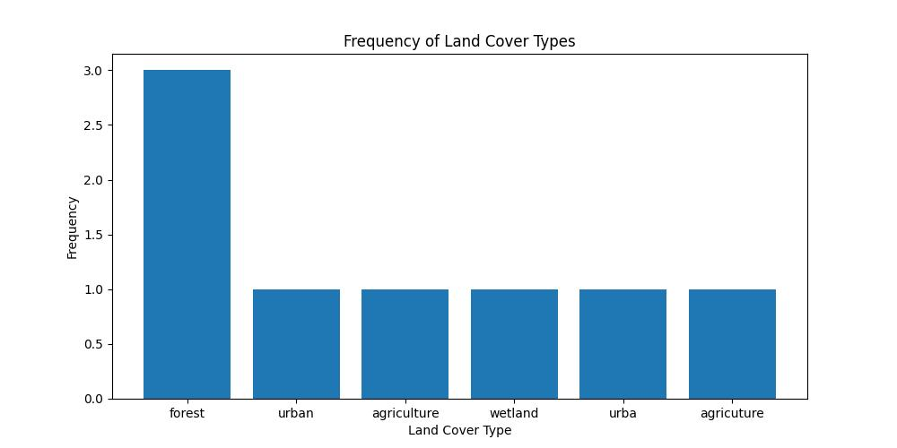

Figure 1: EDA with a single categorical variable using matplotlib

From the bar chart we can see that there are some immediate problems apparent with this data. We can identify a data quality problem in the **land_cover** variable – i.e. there are apparent misspellings or inconsistencies in the land cover type names (e.g., "urba", "agricuture"). This issue can be addressed by cleaning the data, such as by correcting the misspelled land cover type names – or more preferably, mapping them to a standardized set of land cover categories – or better yet, a categorical integer encoding (e.g. pandas categorical variable).

**EDA for Single Numerical Features**

Numerical (quantitative) variables represent quantities or measurements. They can be manipulated using mathematical operations and can take any value within a specified range - depending on the contstraints inherent in the underlying phenomenom represented by the data, the data collection methods, and design of the dataset itself.

Numerical variables can be classified into two distinct types:

1. **Discrete numerical variables:** These variables represent countable values, typically integers, which can only take specific values within a given range. Discrete variables often represent counts or occurrences of events, such as the number of people living in a given geographic area of interest (AOI).
2. **Continuous numerical variables:** These variables represent continuous values that can take any value within a given range, including decimals. Continuous variables often represent measurements, such as temperature, elevation or distance. They can be measured with varying levels of precision, depending on the measurement tools or techniques used.

Numerical variables are primarily analyzed in EDA using the following methods:

* **Descriptive statistics:** Calculating measures of central tendency (e.g., mean, median, mode) and measures of dispersion (e.g., range, variance, standard deviation) to summarize and describe the distribution of numerical data.
* **Visualization:** Creating visual representations of the distribution, such as histograms or box plots.

The histogram below shows an example of numerical data represented by a visualization of the distribution of recorded elevation (meters) in a toy dataset.

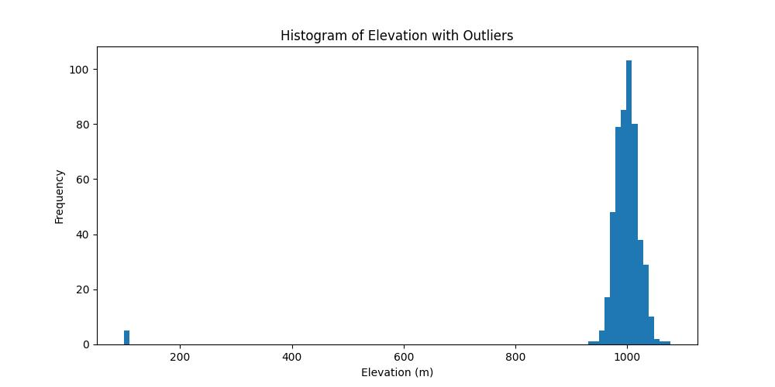

Figure 2: EDA with a single numerical variable using matplotlib

From the histogram we can identify possible erroneous data points in the **elevation** variable. The first giveaway is the large x-axis range output by the plotting program. We can see that the distribution is concentrated in the far right of the plot, and appears to be normally distributed with a mean of approximately 1000 meters. However, on close inspection we can see outlier values on the far left around 100 meters. Assuming this example is taken from an AOI in Rwanda, we would not expect elevation values of 100 meters. Therefore these values are likely erroneous – potentially a result of a missing digit during data entry. This issue can be addressed by cleaning the data, such as by removing or replacing the outlier values with suitable values (e.g., mean, median, or interpolated values).

**EDA for Multiple Features**

The use of multiple features (i.e. multivariate) analysis in EDA refers to the process of examining and analyzing multiple variables simultaneously to uncover patterns, trends, relationships, and potential anomalies within the data. Multivariate EDA helps in understanding the complex interactions and dependencies between variables, which can be critical for building accurate models and making informed decisions. Some common techniques used in multivariate EDA include:

* **Scatter plots:** A simple scatter plot represents **two variables** using points on a grid and provides an easily accessible display of the relationship (if any) between the two variables (ref. example below). Scatter plots help in identifying linear or non-linear relationships, clusters, or potential outliers among variables. Scatter plots are often represented en masse during EDA for a subset of variables in a dataset using a pairs plot. This allows us to quickly view and compare the relationships between many variables simultaneously.
* **Heatmaps:** A heatmap is a graphical representation of data using color gradients to represent the values of a matrix. Heatmaps can be used to visualize the relationships or dependencies between **three variables**.
* **Advanced:** Other, more advanced statistical and machine learning techniques exist for analyzing multiple variables, such as: correlation analysis, principal component analysis (PCA) and cluster analysis. However these techniques are not normally employed during EDA for data cleaning purposes, unless there is a specific requirement for more in-depth analysis.

The scatter plot below shows an example of two numerical variables from a toy dataset. The variables describe precipitation in millimeters and average temperature in Celcius for a set of geographically proximate locations (e.g. towns within the same region).

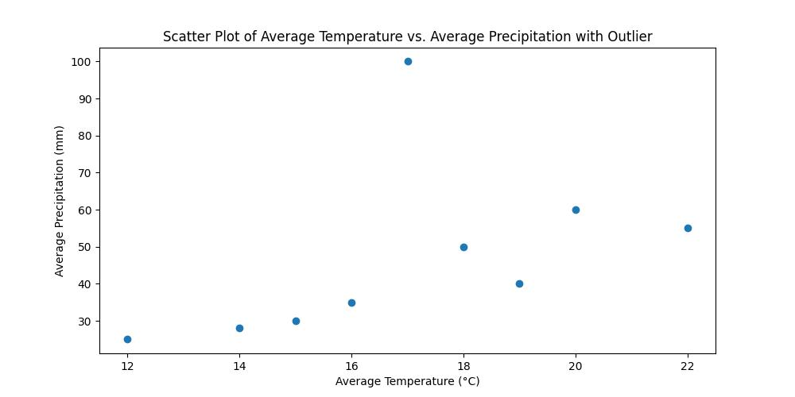

Figure 3: Multivariate EDA using matplotlib

The plot shows a clear positive correlation between temperature and precipitation. The trend appears to show that average rainfall increases (from about 25mm to 60mm) as the temperature increases correspondingly (from around 12C through 22C).

In addition to this observation, we can also see an outlier data point which defies the trend – i.e. there is a location in the dataset for which we have a recorded average temperature of 17°C and an average precipitation of 100 mm. This **outlier is not easily identifiable when examining the temperature or precipitation data individually**, as the values of 17°C and 100 mm are within the range of the other data points. However, when **visualizing the relationship between the two geospatial variables** using the scatter plot, the **outlier becomes visible**.

This type of outlier detection can help us identify data quality issues, such as data entry errors or measurement errors, which may require further investigation during the data cleaning process.

**5.2 Data curation with image datasets**

Image data is widely used in various applications, from computer vision to remote sensing, and plays a key role in enabling machines to understand and interpret visual information. Proper curation and preprocessing of image data is essential to facilitate high performance in machine learning models, as it directly impacts the model's ability to learn from the data and make accurate predictions. In this section we will cover several essential components of image data curation and preprocessing, including:

* Image preprocessing
* Augmentation
* Standardization
* Enhancement
* Exploratory Data Analysis (EDA) for Image Data

With this knowledge, we will have ensured a basis for optimizing image data for the development of robust and accurate computer vision applications. It is important to remember at this point, that the methods discussed in this section can be applied in a general sense to all types of image data - including EO data. In fact, some of the examples used below have been taken from EO and remote sensing contexts. In section 5.3 we will build on these general techniques, and look at additional image processing methods for EO data specifically.

**Image Preprocessing**

Foundational steps in preparing image data for machine learning, including resizing, cropping, and converting between different color spaces. These techniques ensure the consistency of input data and improve the efficiency of the training process. Preprocessing techniques include the following:

* **Resizing:** Resizing is used to change the size of an image to match the input size required by the machine learning model. For example, if the model requires images of size 224x224 pixels, we can resize all images in our dataset to this size using a python library like OpenCV.
* **Reorienting:** Reorienting is used to change the orientation of an image so that it matches the orientation required by the machine learning model. For example, if the model requires all images to be in landscape orientation, we can reorient all images in our dataset to landscape orientation using a python library like Pillow.
* **Color correction:** Color correction is used to adjust the color balance and brightness of an image so that it matches the requirements of the machine learning model. For example, if the model requires all images to be grayscale, we can convert all images in our dataset to grayscale using OpenCV or similar.

The figure below demonstrates these concepts using an image taken by a drone and preprocessed using the python OpenCV library. The image has been resized to 250x250 pixels, rotated, and color corrected to grayscale. In this particular example, the resizing process has stretched the image considerably beyond its original rectangular aspect ratio. It is important to be aware of the transformations that will be performed on our data during preprocessing. In this example, the resizing may have an effect on downstream analyses and models. For instance, in a remote sensing scenario such as this, the calibration of pixels vs. distance has been affected - likely resulting in inaccurate distance calibration with other images in the training set (assuming the other images have different initial aspect ratios). Depending on the use case, it may have been better in this case to first crop the original image to a square aspect ratio, prior to the subsequent preprocessing transformations.

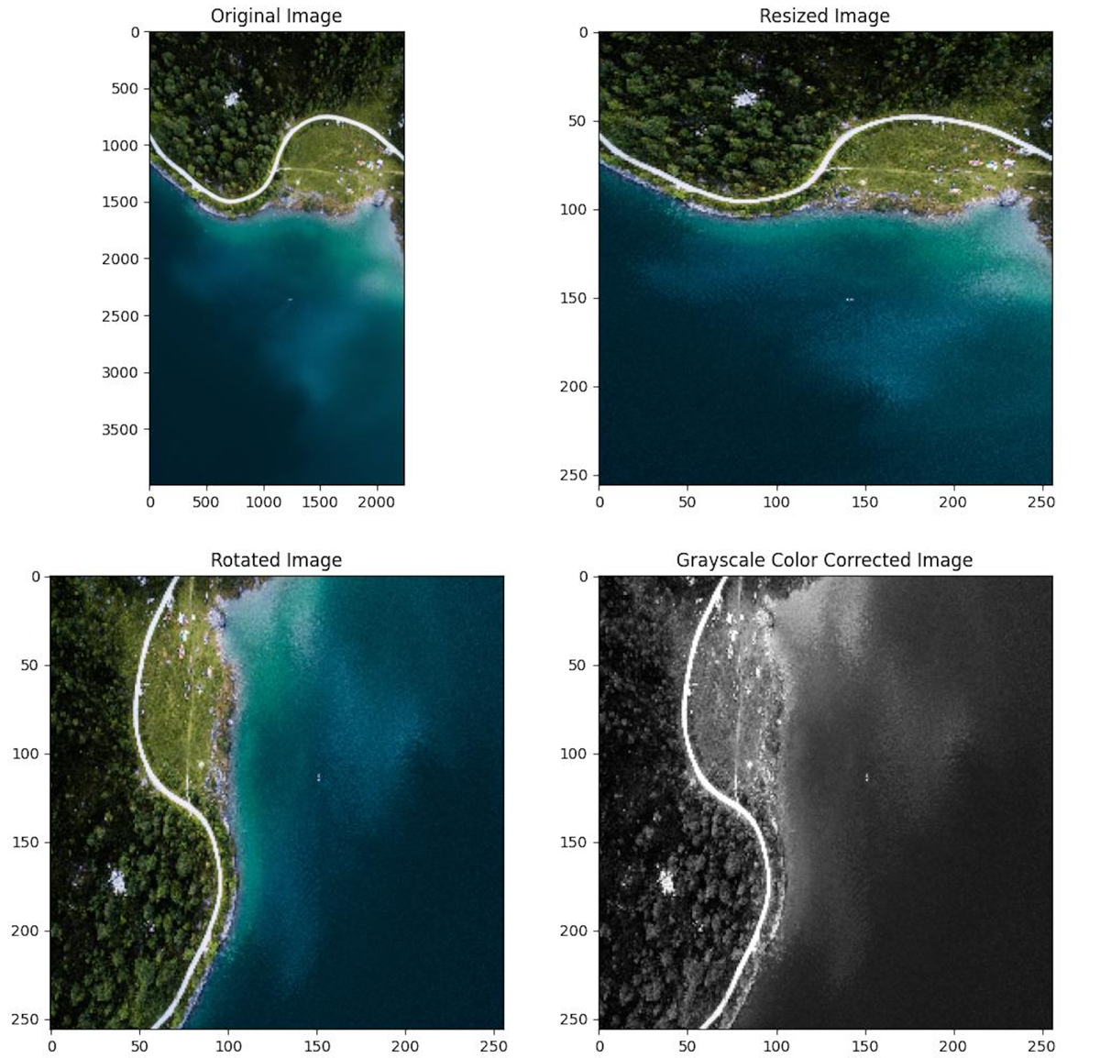

Figure 4: Image preprocessing using openCV[1]

Image pre-processing is a key consideration in computer vision with regard to **resources and performance**. Model training time and inference speed are directly affected by input data volume. If input images are particularly large, reducing the size of these images will dramatically improve model training time without significantly reducing model performance. For example, the standard size of images on an iPhone 11 are 3024 × 4032 pixels. The machine learning model Apple uses to create masks and apply Portrait Mode performs on downsampled versions of these images (at half the size) before the output is rescaled back to full size.  
  
Resizing is also an essential step in most computer vision data cleaning pipelines. Convolutional neural networks (CNNs), a common architecture in computer vision, require that all images are the same sized arrays. If our input images have differing sizes, the model will likely produce an error, or otherwise not perform as expected.

Many of the image pre-processing methods used are also used for image augmentation, which we will discuss in the next section. For more background information, please read: <https://blog.roboflow.com/why-preprocess-augment>.

**Image Augmentation**

Augmentation is a technique used in machine learning data curation for increasing the size and diversity of training data. In the specific context of computer vision, this means applying various transformations, such as rotation, flipping, scaling and other image processing techniques to image data. We will discuss different augmentation techniques and their application in improving model generalization and preventing overfitting.

Using image augmentation we create different versions of training data in order to expose the model to a wider array of training examples. For example, randomly altering rotation, brightness, or scale of an input image requires that a model consider what an image subject looks like in a variety of situations. The figure below shows an example of image augmentation using an EO layer built for classifying land cover. The augmentation was conducted using the python augmentor library[2], and shows numerous transformations of the original image[3].

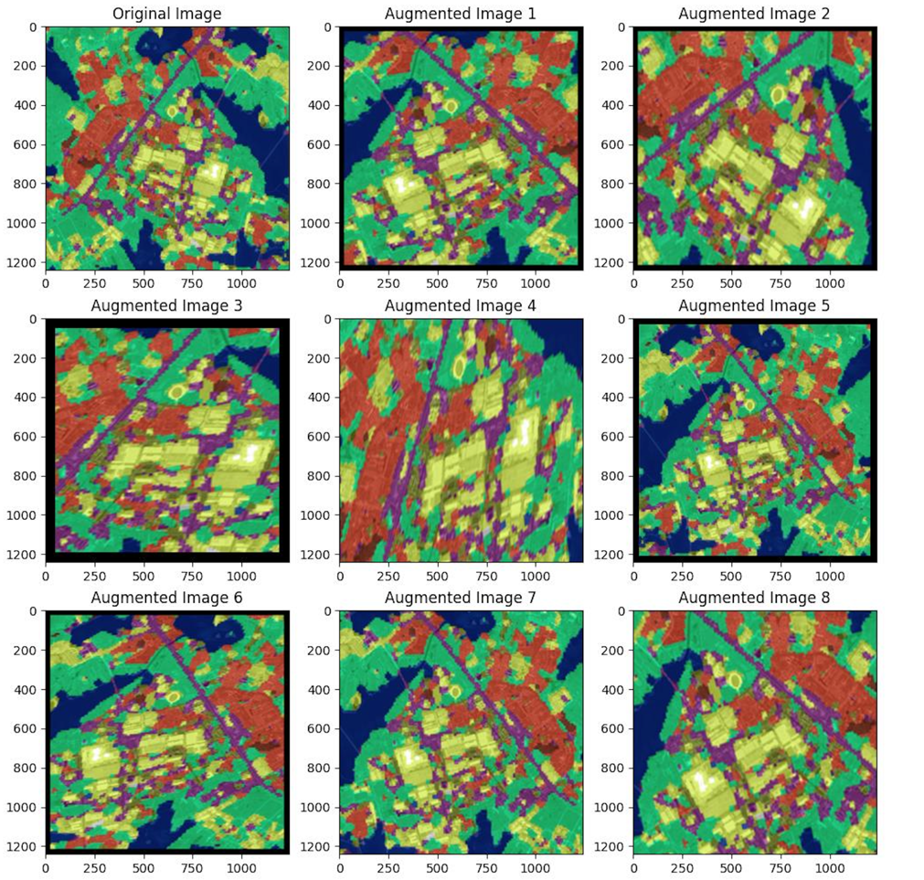

Figure 5: Image augmentation using augmentor

**Image augmentation manipulations are forms of image preprocessing**, but there is a critical difference: while image preprocessing steps are applied to training data, validation/testing data and analytical data, image **augmentation is only applied to training data**. Knowing the context for data collecting and model inference is required to make informed preprocessing and augmentation decisions.

As with other computer vision tasks, data augmentation can be useful in the context of EO and remote sensing. It’s rare to have a dataset that accounts for every real-world scenario a model may encompass. To expand on this, the key reasons for using data augmentation in the EO context are as follows:

* **Diversity and Variability:** EO data may not always capture the full range of variability present in the real world due to limitations in temporal, spatial, and spectral resolutions. Data augmentation can help introduce additional variability into the dataset, enabling the model to learn more robust and generalizable features.
* **Rare or Imbalanced Classes:** In some cases, specific land cover types or other target phenomena may be underrepresented in the available data. Data augmentation can be used to create more samples for these rare or imbalanced classes, thereby improving the model's ability to recognize and classify them.
* **Prevent Overfitting:** Even when we have a large amount of training data, it is still possible for ML models to overfit. Data augmentation helps prevent overfitting by generating new samples with slightly different perspectives. This forces the model to learn more generalizable features.
* **Limitations of Data Collection:** EO data may suffer from issues like cloud cover, atmospheric interference, or sensor degradation, which can lead to missing or noisy data[4]. Data augmentation can help compensate for these limitations by creating new samples based on the available data, allowing the model to learn from a more complete representation of the underlying phenomena.

**Image Standardization**

Standardization is a key process in analytical and many machine learning workflows. It ensures that input data is provided to the model on a consistent scale, which helps improve the convergence and stability of the learning process. In the context of image data, this includes pixel intensity normalization and zero-centering.

There are several aspects of image standardization (also known as whitening) which are often used in computer vision workflows:

* **Mean Subtraction and Standard Deviation Scaling (“Whitening”):** Another common technique for standardizing images is subtracting the mean pixel value and dividing by the standard deviation of the dataset. This ensures that the pixel values have a mean of 0 and a standard deviation of 1. For large datasets, it's common to calculate the mean and standard deviation per color channel across the **entire dataset** and use these values for standardization. Standardization can be performed on image data using numpy or more specialized image libraries. An example of whitening is demonstrated in the figure below.
* **Pixel Value Scaling:** Pixel values in images usually range from 0 to 255[5]. Scaling these values to a smaller range, such as [0, 1] or [-1, 1], can help improve the convergence of the model during training. As with whitening, pixel value scaling can be performed on image data using numpy or more specialized image libraries.
* **Color Space Conversion:** Images in a dataset may be represented in different color spaces (e.g., RGB, HSV, or grayscale). Converting images to a consistent color space is essential for machine learning models to work effectively. In python, we can use OpenCV's cv2.cvtColor() function to convert images between different color spaces.

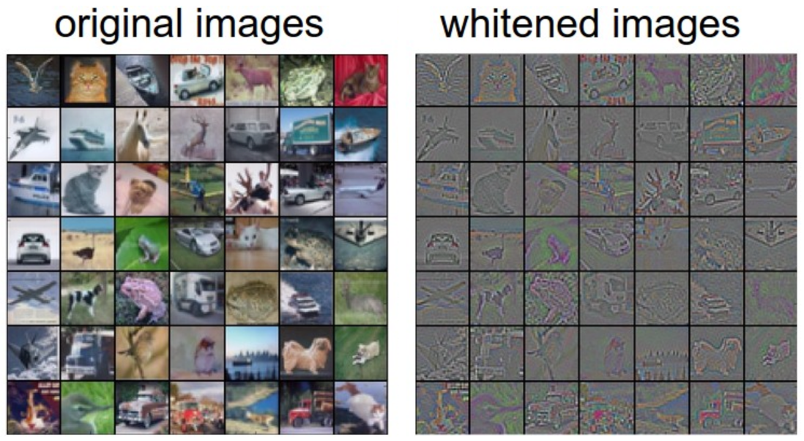

Figure 6: Before and after image standardization[6]

**Image Enhancement**

Image enhancement techniques aim to improve the quality and interpretability of the images, which can be particularly important in cases where the raw data is noisy or degraded. While there are wide variety of image enhancement techniques available, we will focus on common techniques used for ML training data curation, such as contrast stretching, histogram equalization, and morphological operations to optimize image data for machine learning tasks.

**Contrast stretching** (also known as normalization) is an image processing technique used to improve the visual quality of an image by adjusting its intensity levels. The goal of contrast stretching is to expand the range of pixel values in an image to span the full range of the desired output range, thereby making the image easier to analyze and interpret.

In the context of computer vision training data curation, contrast stretching can be beneficial as it enhances the visibility of features in the image, making it easier for machine learning models to learn and detect patterns. This is particularly useful for images with poor contrast, where the range of pixel values is limited or concentrated around a narrow range, which can make it challenging for the model to discern between different features.

Contrast stretching works by transforming the pixel values in the image according to a linear or non-linear function, such that the minimum pixel value is mapped to the lower limit of the desired output range, and the maximum pixel value is mapped to the upper limit. Contrast stretching can be easily accomplished in python using libraries like numpy and openCV, as well as more specialized libraries.

**Histogram equalization** is a related image enhancement technique that aims to improve the contrast of an image by redistributing the pixel values to have a more uniform distribution. This technique is useful for the same reasons as contrast stretching. Both methods aim to improve image contrast, but they do so in different ways. While contrast stretching is a linear technique that scales the pixel values, histogram equalization is a non-linear technique that redistributes the pixel values based on their cumulative distribution function (CDF). Histogram equalization is particularly useful when the image has a non-linear distribution of pixel values, as it can enhance the contrast more effectively than linear contrast stretching. The technique is easily implemented in python using the openCV library.

The figure below demonstrates the application of histogram equalization to an image. The post-equalization image is much easier to visually interpret, and the associated histogram shows a much more uniform distribution.

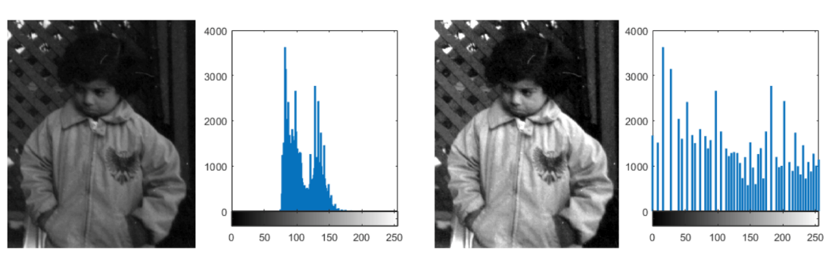

Figure 7: Before histogram equalization (left), After histogram equalization (right)[7]

**Morphological operations** are image enhancement techniques that focus on the shape and structure of objects within an image. They are particularly useful for enhancing, refining, and simplifying binary and grayscale images in the context of general computer vision training data curation. However, they can also be useful in the context of geospatial image enhancement. Geospatial images, such as satellite imagery or aerial photographs, often contain noise, small artifacts, gaps, or connected objects that can impact the performance of machine learning models.

These techniques work by applying a structuring element (a small binary or grayscale matrix) to the input image, comparing the element to the image's pixel neighborhoods, and updating the central pixel value based on the operation being performed. The two main morphological operations are dilation and erosion:

* **Dilation:** This operation expands the shapes in the image by adding pixels to the boundaries of the objects. Dilation can be used to fill small holes or gaps, connect nearby objects, or make objects more prominent. It can also increase the size of noise and artifacts, so it's often used in combination with erosion to balance the effects.



Figure 8: Dilation adds pixels to image boundaries making them more visible compared to the background[8]

* **Erosion:** This operation shrinks the shapes in the image by removing pixels from the boundaries of the objects. Erosion can be used to eliminate small artifacts, disconnect connected objects, or reduce the size of objects. It can also remove fine details or thin structures, so it's often used in combination with dilation to balance the effects.



Figure 9: Erosion removes pixels causing while decreasing background noise, causing the structure to stand out

Combined morphological operations, such as opening (erosion followed by dilation), closing (dilation followed by erosion), and morphological gradient (difference between dilation and erosion), can also be used for various image enhancement tasks.

**EDA for Image Data**

EDA is an important step in understanding the characteristics and structure of our datasets. We will touch on general EDA techniques for image data, including visualizations, summary statistics, and the identification of potential issues or biases in the data. EDA for image data is not as easy as structured data. Generally summary analyses involve the use of metadata to help understand the dataset. Some common EDA techniques for image data are:

* **Image manual inspection:** Examining a random sample of images can give us an initial understanding of the data, identify potential issues (e.g., noise, artifacts, or varying illumination conditions), and reveal any preprocessing requirements. A common practice is to randomly sample 100 images from each class in the dataset and visualize them manually. Dataset inspection tools such as FiftyOne[9] can assist with this process.
* **Image statistics:** Computing basic image statistics, such as the mean, median, standard deviation, and histogram of pixel values, can help us understand the distribution of pixel intensities and identify any potential issues, such as over- or under-exposed images.
* **Image summarization:** Computing an average image for each class in a dataset and comparing the classes can sometimes yield insights. This is generally only useful when we have **classes with similar overall visual characteristics**. For example, the figure below shows summary images from a pneumonia classification dataset with images representing the average healthy lung image, and average infected lung image. In this case, the summary images may reveal aspects of the two classes that can be used to differentiate them.

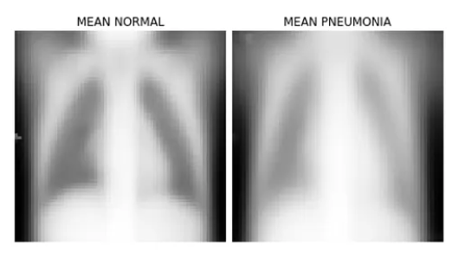

Figure 10: Summary images by class in a pneumonia lung imaging dataset[10]

* **Image class distribution:** For supervised learning tasks, analyzing the distribution of classes in the dataset can help us identify any class imbalance issues that may require data augmentation or other techniques to address.
* **Color analysis:** Analyzing the distribution of colors in the dataset can provide insights into the dominant colors and color combinations, which can inform the choice of color spaces or color-based features for further analysis.
* **Dimensionality reduction:** Techniques like Principal Component Analysis (PCA) or t-distributed Stochastic Neighbor Embedding (t-SNE) can be used to reduce the dimensionality of image features, enabling visualization and exploration of the high-dimensional image data in a more manageable low-dimensional space.

The figure below provides an example of applying t-SNE to the MNIST dataset. The MNIST dataset is an image dataset of handwritten digits. Each image is 28x28 pixels and the dataset contains 10 classes (the digits 0 through 9). From the plot, 10 clusters are clearly apparent in two-dimensional space corresponding to the 10 classes in the dataset, with very little obvious overlap between clusters.

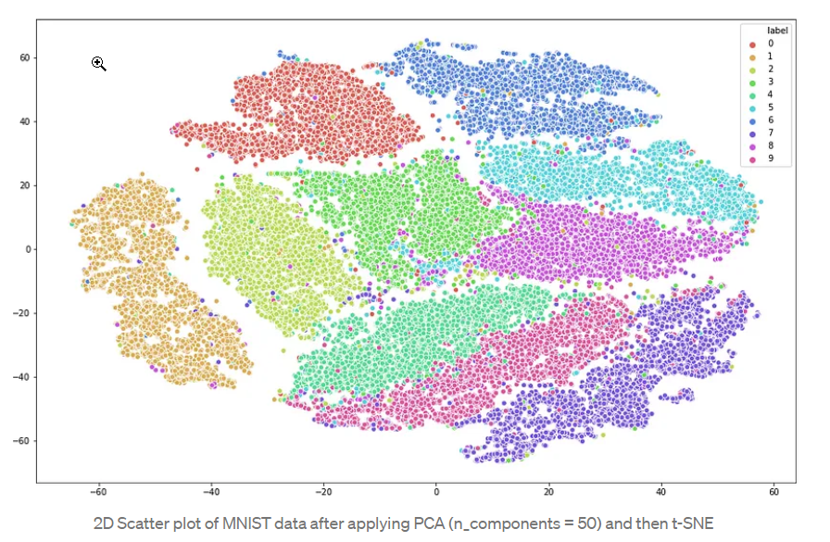

Figure 11: Image EDA using t-SNE (MNIST dataset)[11]

**5.3 Data curation with EO data**

Preparing Earth Observation (EO) images for machine learning training datasets requires the application of a variety of techniques to ensure data is clean, well-structured, and suitable for model ingestion. Many of the basic image processing methods discussed in the previous section apply equally to EO data, such as image preprocessing, enhancement, standardization and augmentation. These concepts will be applied to EO data in the exercises. We will therefore only cover the following EO-specific concepts in section 5.3:

* Radiometric preprocessing
* Geometric preprocessing
* Alignment and Resampling
* Labeling and annotation

**Radiometric preprocessing**

Radiometric preprocessing of satellite image data involves correcting the images for sensor-related distortions and atmospheric effects to ensure that the pixel values accurately represent the radiance or reflectance of the Earth's surface. Though **in many cases, curated EO datasets available to us already include radiometric corrections** it is important to understand the concepts. We will discuss some key techniques and considerations for radiometric preprocessing of satellite image data:

**Atmospheric correction:** Satellite images are affected by atmospheric conditions, such as absorption and scattering of solar radiation by gases, aerosols, and water vapor (commonly seen as general haze in EO images). Atmospheric correction aims to remove these effects to reduce interference with other analytical attributes. Several established methods are available to address atmospheric correction:

Dark Object Subtraction (DOS) Also known as ‘dark pixel’, DOS is an empirical method that assumes the darkest pixels in an image correspond to non-reflective surfaces (e.g., deep water or shadows) and have zero surface reflectance. The atmospheric path radiance is estimated from these dark pixels, and then subtracted from the entire image to retrieve the surface reflectance values. DOS is a simple and fast method for things like haze removal, but may not be suitable for scenes with complex atmospheric conditions or a lack of dark objects. In such cases, more advanced atmospheric correction methods like radiative transfer models (e.g., 6S, ATCOR) may provide better results.

DOS can be implemented using basic python (i.e. numpy) by calculating the minimum pixel values in the image and subtracting them from the entire image. Rasterio also includes methods for DOS.

**Cloud and cloud shadow masking:** Clouds and cloud shadows can significantly affect the pixel values in satellite images, making it difficult to retrieve accurate surface reflectance values. Cloud and cloud shadow masking involves identifying and removing (or replacing) the cloud - and cloud shadow - affected pixels in the images, resulting in cleaner and more reliable datasets. Various cloud and cloud shadow masking techniques are available, each with its own strengths and weaknesses:

* **Fmask (Function of mask):** Fmask is an automated cloud and cloud shadow detection algorithm specifically designed for Landsat images (Landsat 4-8). It uses a combination of spectral, spatial, and temporal information to identify clouds, cloud shadows, and snow/ice pixels. Fmask is widely used in the remote sensing community due to its accuracy and robustness.

The python-fmask library is a Python implementation of the Fmask algorithm. It can be used to process Landsat images and generate cloud and cloud shadow masks that can be further used in image processing and analysis workflows.

* **Automated Cloud-Cover Assessment (ACCA):** ACCA is an automated cloud detection algorithm developed for Landsat 7 Enhanced Thematic Mapper Plus (ETM+) data. It uses a series of spectral tests and thresholds to identify cloud pixels in the images. While ACCA is relatively fast and easy to implement, its performance can be affected by the choice of thresholds and the presence of bright surfaces like snow or ice.

ACCA can be implemented using numpy and basic image processing libraries like rasterio.

* **Sentinel-2 Cloud Masking (Sen2Cor):** Sen2Cor Sen2Cor is an atmospheric correction processor developed by the European Space Agency (ESA) specifically for Sentinel 2 images. It includes a cloud masking module that uses a combination of spectral tests, spatial information, and ancillary data to identify cloud pixels in the Sentinel 2 images.

Sen2Cor can be installed and executed as a standalone processor, and its output, including cloud masks, can be read and processed using Python libraries like rasterio and xarray.

* **Machine Learning-based methods:** Recently, ML and deep learning (DL) techniques have been applied to cloud and cloud shadow detection in satellite images. These methods can learn complex features and patterns from large training datasets and achieve high accuracy in cloud and cloud shadow detection.

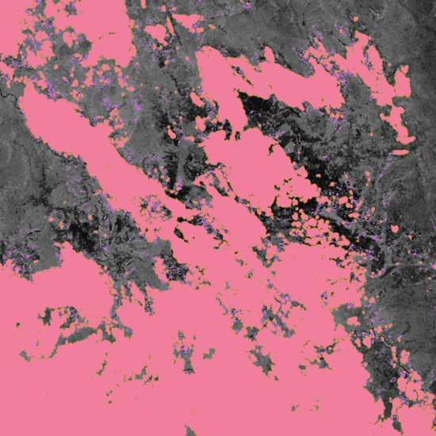

Figure 12: Cloud masking in earth observation image data

**Radiometric normalization:** Satellite images acquired at different times or by different sensors can have varying radiometric properties due to differences in sensor characteristics, atmospheric conditions, or illumination conditions. Radiometric normalization involves adjusting the pixel values of one image to match the radiometric properties of a reference image, making the images more comparable for temporal or multi-sensor analysis. Common radiometric normalization techniques include histogram matching, linear regression, and the relative normalization approach.

Though it is **highly unlikely** that you will need to delve into the details of satellite sensor calibrations and radiometric normalization, there are some edge cases where summary knowledge of this can be useful. For instance, in the case of long scale time series analysis, it may be necessary to harmonize between sensors both on the same spacecraft, or between different satellites (or satellite platforms). One such example is the harmonization of the DMSP and VIIRS nightlights dataset[12].

**Geometric preprocessing**

Geometric preprocessing involves the correction of EO images due to various errors introduced during data collection. Common geometric errors necessitating correction include instrument error, earth rotation during image acquisition and satellite platform instability. These errors can be addressed using image alignment.

Image alignment is the process of aligning two or more images of the same scene, acquired at different times, angles or from different sensors - by matching common features or landmarks. This is important for multi-temporal or multi-sensor analysis, where images need to be accurately aligned to ensure a correct comparison or fusion of the data. Image alignment can be performed using various methods, such as feature-based, area-based, or template matching techniques. When aligning satellite images, factors like the spatial resolution, image quality, and the presence of distinctive features or landmarks can affect the accuracy of the process.

**In almost all many cases, EO datasets made available to analysis already include geometric corrections**. Therefore, we will not discuss specific preprocessing techniques.

**Resampling**

Resampling and alignment techniques ensure that images from different sensors, dates, or resolutions can be accurately compared or combined for further analysis or machine learning applications. These processes help to standardize the spatial characteristics of the data, making it consistent and suitable for downstream processing.

OpenCV, scikit-image, and rasterio are popular python libraries for image processing and can be used to perform image alignment tasks. These libraries provide various feature detection, matching, and transformation functions that can be applied to align satellite images accurately. OpenCV and scikit-image offer feature-based methods (e.g., SIFT, SURF, ORB) to detect and match key points between two images. Once the key points are matched, libraries like OpenCV and scikit-image can also be used to compute the transformation matrices (e.g., affine, projective, or polynomial) that align the images. Rasterio, on the other hand, can be used to apply the computed transformation to the satellite images and create co-aligned images in a common coordinate system.

**Resampling:** Resampling is the process of changing the pixel size or spatial resolution of an image, either by interpolation or aggregation. This is often required when combining images with different resolutions or when resampling an image to a specific resolution for a particular application. Additionally, resampling is used in feature extraction by the use of different filters such as Gaussian and median filters. Common resampling methods include nearest-neighbor, bilinear, and cubic convolution interpolation techniques.

* **Downsampling:** reduces the size (number of pixels) of an image for a given spatial area (spatial resolution). This results in **decreased spatial resolution**, and the number of rows and columns in the image will decrease. This process can lead to a smaller file size and a coarser representation of the data. Downsampling can be beneficial for reducing storage and computational requirements, but it may also result in a loss of detail and spatial information. Depending on the resampling method used, some features or patterns in the data may become less discernible or even disappear altogether.

The figure below exemplifies this property. As demonstrated, the resulting image (represented by the matrix on the right) has lost information, in this case through a gaussian blurring process.

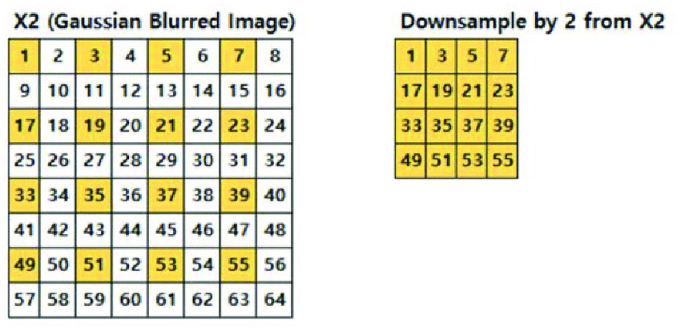

Figure 13: Conceptualization of downsampling (using Gaussian blurring)[13]

* **Upsampling:** increases the size of an image for a given spatial area. This results in **increased spatial resolution**, and the number of rows and columns in the image will increase. This process can lead to a larger file size and more detailed representation of the data. However, keep in mind that upsampling cannot recover information that was not present in the original lower-resolution image. The increased detail may be interpolated or estimated, which can result in a smoother appearance but may not accurately reflect the actual ground truth.

The figure below represents the basic concept of upsampling. In this case, no interpolation algorithm has been applied. The new pixels are simply scaled (squared) from each pixel in the original.

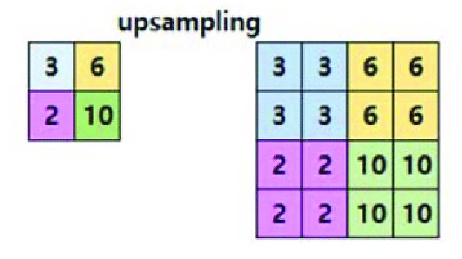

Figure 14: Conceptualization of upsampling (without interpolation)13

When resampling satellite images, it is essential to consider the trade-offs between the spatial resolution, image quality, and computational requirements. For instance, downsampling high resolution images may involve significant loss of information, but more efficient compute; whereas upsampling low resolution images may have a major impact on model training and inference resource requirements. The choice of resampling method can also affect the image quality, as some methods (e.g., nearest-neighbor) can introduce artifacts or aliasing, while others (e.g., cubic convolution) may preserve more details but require more computational resources.

GDAL, rasterio, and xarray are common python libraries for geospatial data processing and can be used for resampling satellite images. GDAL provides functions to read, resample, and write satellite images with different spatial resolutions. It supports various resampling methods, such as nearest-neighbor, bilinear, and cubic convolution, and can handle different coordinate systems and projections. Rasterio can also be used to perform resampling tasks using its built-in resampling functions and coordinate system handling capabilities. Xarray, on the other hand, provides a high-level interface for working with multi-dimensional geospatial data and can be used to resample and align satellite images along with their associated metadata.

**Pansharpening:** Pan sharpening is a technique used to enhance the spatial resolution of a multispectral image by combining it with a high-resolution panchromatic image. The goal of pan sharpening is to produce a single, high-resolution image that retains the spectral information of the multispectral image and the spatial detail of the panchromatic image.

Pan sharpening works by first registering (aligning) the multispectral and panchromatic images to ensure that they are aligned and have the same geographic reference. Next, the panchromatic image is resampled to match the lower spatial resolution of the multispectral image. The resampled panchromatic image is then used to enhance the spatial resolution of the multispectral image by adding the high-resolution detail from the panchromatic image to each band of the multispectral image.

There are several methods for pan sharpening, including the IHS (Intensity-Hue-Saturation) method, the Brovey method, and the PCA (Principal Component Analysis) method, among others. Each method has its own strengths and weaknesses, and the choice of method depends on the specific requirements of the data and the goals of the analysis.

Pan sharpening is commonly used in EO to improve the visual quality of the data, to enhance the detail of the data for mapping and land use analysis, and to support the interpretation of the data for scientific studies. The technique is especially useful for applications where high spatial detail is important, such as urban mapping and land use analysis, where the additional detail provided by the panchromatic image can be used to distinguish between different types of land use and land cover.

Multiple python libraries (e.g. rasterio, gdal, numpy, scipy) provide tools for performing pan-sharpening using various methods, including the IHS (Intensity-Hue-Saturation) method, the Brovey method, and the PCA (Principal Component Analysis) method, among others.

**Object Identification**

**Edge detection**: Edge detection is a fundamental image processing technique used to identify and extract boundaries or discontinuities in digital images. In the context of Earth observation, edge detection is employed for various remote sensing applications, such as delineating land cover types, detecting changes in landscapes, and identifying man-made or natural features.

The primary goal of edge detection in Earth observation is to identify significant **transitions in pixel values**, which represent changes in features such as land cover, vegetation, water bodies, or urban structures. Various edge detection techniques can be used for this purpose, including:

1. Gradient-based methods: These methods involve calculating the first or second derivative of the image to identify areas with high intensity variation. Common gradient-based edge detection techniques include the Sobel, Prewitt, Scharr, and Canny operators.
2. Laplacian-based methods: These methods compute the second derivative of the image, focusing on areas where the intensity changes rapidly in multiple directions. The Laplacian of Gaussian (LoG) is a popular Laplacian-based edge detection technique.
3. Morphological methods: These techniques involve using structuring elements to identify boundaries between different regions in an image. Morphological edge detection techniques, such as erosion, dilation, opening, and closing, are particularly useful for binary images.
4. Statistical methods: These methods analyze the statistical properties of pixel neighborhoods to identify edges. Examples include the local variance method and the entropy-based method.
5. Machine learning and deep learning methods: Modern approaches incorporate machine learning and deep learning techniques for edge detection. Convolutional Neural Networks (CNNs) and other deep learning models can be trained to automatically learn and extract edges from Earth observation images.

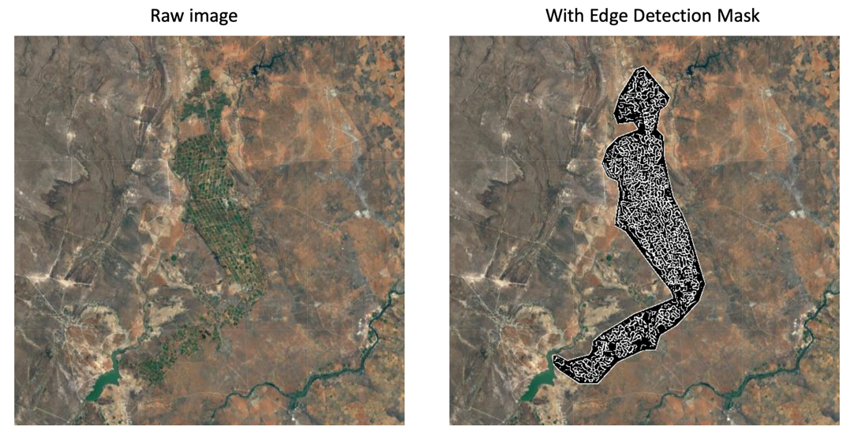

Figure 15: Edge detection in earth observation

Edge detection in Earth observation is used in various applications, such as:

* Land use and land cover classification
* Change detection for monitoring deforestation, urbanization, or desertification
* Identifying water bodies, such as lakes, rivers, and coastlines
* Detection of roads, buildings, and other infrastructure
* Geological and geomorphological studies, such as fault line identification and landslide monitoring

Moreover, edge detection can be used to create **machine learning training data**, particularly for tasks involving object recognition, segmentation, and classification in images. By extracting edges from images, you can obtain valuable information about the boundaries, shapes, and structures of objects, which can serve as features for machine learning models[14]. The use of edge detection in ML training data creation falls primarily under the following processes:

1. Ground truth generation: Edge detection can be used to generate ground truth labels for image segmentation tasks. By applying edge detection to manually annotated images or images with known object boundaries, you can create pixel-level masks that represent the object's boundaries. These masks can then be used as ground truth labels for training segmentation models.
2. Feature extraction: Edges can be used as features for training machine learning models in tasks such as object recognition, classification, and detection. By extracting edges from images, you can obtain a simplified representation of the image that emphasizes object boundaries and reduces the influence of irrelevant information, such as texture or lighting variations. These edge-based features can be used as input for traditional machine learning algorithms, like Support Vector Machines (SVMs) or Random Forests, or as additional input channels for deep learning models like Convolutional Neural Networks (CNNs).
3. Pre-processing for object detection: In object detection tasks, edge detection can be used as a pre-processing step to identify potential regions of interest (ROI) that contain objects. By extracting edges and applying further processing techniques like clustering or morphological operations, you can isolate ROIs that are likely to contain objects. These ROIs can then be used as input for object detection models, reducing the search space and computational complexity of the task.

Several python libraries facilitate edge detection including opencv, scikit, rasterio, and gdal. We will be exploring edge detection in the exercises using the Canny gradient-based method and the Google Earth Engine python API.

**Labeling and annotation**

Labeling and annotation of satellite image data is the last step in creating training datasets for machine learning applications. Accurate labels and annotations help in training robust models capable of producing reliable predictions. We will cover the practice of labelling and annotation for EO data in the Module 6 exercise, but here we will briefly discuss the common approaches.

**Manual Labeling and Annotation:** Manual labeling involves experts visually inspecting satellite images and manually annotating the features of interest, such as roads, buildings, vegetation, or water bodies. This can be done using GIS software or custom annotation tools that allow users to draw polygons, lines, or points over the satellite images to create labeled data. We introduced this method in Module 3 using a tablet and simple Android app.

While manual labeling can produce highly accurate annotations, it can be time-consuming and labor-intensive, especially for large-scale or high-resolution datasets. Additionally, the quality of the annotations may vary due to human errors or inconsistencies between different annotators. To mitigate these issues, it is essential to establish clear labeling guidelines and quality control procedures to ensure the consistency and accuracy of the annotated data.

**Semi-Automated Labeling and Annotation:** Semi-automated labeling combines manual labeling with automated techniques, such as image segmentation and object detection to assist the annotators in the labeling process. These methods can help in identifying and extracting features of interest more efficiently, reducing the manual effort required for labeling.

Although semi-automated labeling can speed up the annotation process, it may still require manual verification and refinement to ensure the accuracy of the extracted features. The choice of automated techniques and associated parameters can also affect the quality of the annotations, making it crucial to select the most appropriate method based on the characteristics of the satellite images and the specific application requirements.

**Fully Automated Labeling and Annotation:** Fully automated labeling relies on machine learning algorithms or remote sensing techniques to automatically extract features of interest from satellite images and generate labeled data. Examples include supervised classification algorithms for land cover, unsupervised clustering, or spectral indices for vegetation, water, or urban areas.

While fully automated labeling can significantly reduce the manual effort required for annotation, the quality and accuracy of the generated labels depend on the performance of the selected algorithms or techniques. It is essential to carefully validate and assess the quality of the automatically generated labels, using ground truth data or expert knowledge on a sample basis, to ensure the reliability for downstream ML applications.

**Crowdsourcing:** Crowdsourcing leverages the power of a large number of users to create labeled data through platforms like OpenStreetMap or Geo-Wiki. Crowdsourcing can provide valuable information for labeling and annotation of satellite images, but the quality and accuracy of the data may vary depending on the source and the level of user expertise. It is therefore essential to establish quality control measures and validation procedures to ensure the reliability of the data.

One example of of geodata crowdsourcing is BigEarthNet[15] - a large-scale, multi-temporal, multi-sensor remote sensing dataset for land cover and land use mapping. BigEarthNet was created to support research and development in the field of remote sensing and provide a benchmark dataset for evaluating the performance of remote sensing algorithms. The dataset consists of over 20 million images from various satellite platforms, including Sentinel-2, Landsat 8, MODIS, and others. The images are collected from various regions around the world and cover a wide range of land cover and land use types, including urban areas, forests, croplands, wetlands, and more.

BigEarthNet also includes a comprehensive set of **ground truth data**, including reference maps and labels for each image, which can be used to train and evaluate remote sensing algorithms. The ground truth data was collected using a combination of field surveys and remote sensing techniques, and is carefully curated to ensure its quality and accuracy.

**5.4 Visualization of EO data**

As we have learned from previous modules, satellite earth observation data offers a unique perspective of our planet, capturing a wealth of information across various spectral bands. This data is invaluable for a wide range of applications, from environmental monitoring and land-use analysis to disaster management and urban planning. Visualizing and interpreting this data effectively requires a good understanding of the underlying sensor band capabilities, as well as techniques for manipulating bands and feature extraction through band combinations.

In previous modules we covered basic visual exploration of EO datasets using ESA’s EO Browser platform. However, it is **important to have a solid grasp of EO data visualization in the same environment we use for machine learning – i.e. python**. In this section, we will explore these EO visualization topics, focusing on the utilization of common python libraries for data processing and visualization.

In our exploration of EO data visualization in python, we will delve into the intricacies of band stacking, a technique that combines multiple spectral bands of satellite imagery into a single composite image, enhancing the visualization and interpretation of specific features. Furthermore, we will build on learning from Module 2 as we explore how various band combinations can be employed to extract essential information; emphasizing their usefulness in identifying and highlighting features of interest, such as vegetation, water bodies, and built-up areas. The theory discussed in this section is supported by hands-on exercises using widely-adopted python libraries, such as rasterio, numpy, matplotlib, and earthpy.

**EO Satellite Platforms and Spectral Bands**

As we discussed in Module 2, one of the key aspects that make EO satellites useful for producing insights is their ability to capture data across multiple spectral bands. Spectral bands refer to specific ranges of wavelengths within the electromagnetic spectrum, such as visible light, near-infrared (NIR), and shortwave infrared (SWIR) regions. Each spectral band provides unique information about the Earth's surface, as incoming light rays interact differently with different materials and features.

For example, visible light bands (red, green, and blue) are useful for observing general land features, water bodies, and human-made structures. In contrast, the NIR and SWIR bands can provide insights into vegetation health, soil moisture, and mineral composition. By collecting data across multiple spectral bands, Earth observation satellites can capture a comprehensive and detailed view of the Earth's surface, enabling more accurate and effective analysis.

Multispectral and hyperspectral sensors are two common types of sensors found on Earth observation satellites that capture data across multiple spectral bands. Multispectral sensors usually collect data in a limited number of discrete bands (typically between 3 and 15 bands), while hyperspectral sensors collect data across a much larger number of contiguous bands (sometimes more than hundred bands). The increased spectral resolution of hyperspectral sensors allows for more precise identification and classification of materials and features on the Earth's surface.

For the exercises in this course, we will only be working with multispectral data. Let us explore the bands available on one of the common open-source platforms for accessing multispectral EO data: Sentinel 2.

**Sentinel 2**

Sentinel 2 is a series of Earth observation satellites, part of the European Union's Copernicus program, designed for monitoring land and vegetation changes, natural disaster management, and various other applications. The Sentinel 2 mission consists of two identical satellites, Sentinel 2A and Sentinel 2B, carrying a high-resolution multispectral imaging instrument with spatial resolutions between 10 to 60 meters, with a 5-day revisit period. The table below provides a brief overview of the Sentinel 2 bands and their associated analytical use cases:

Table 1: Sentinel 2 spectral bands and use cases[16]

|  |  |  |  |  |
| --- | --- | --- | --- | --- |
| Band | Res-olution | Central Wave-length | Description | Use Cases / Detection |
| B1 | 60 m | 443 nm | Ultra Blue (Coastal and Aerosol) | Coastal water quality and aerosols in the atmosphere |
| B2 | 10 m | 490 nm | Blue | Water bodies and vegetation |
| B3 | 10 m | 560 nm | Green | Vegetation and water bodies |
| B4 | 10 m | 665 nm | Red | Vegetation monitoring and land-use classification |
| B5 | 20 m | 705 nm | Visible and Near Infrared (VNIR) | Vegetation health and stress |
| B6 | 20 m | 740 nm | Visible and Near Infrared (VNIR) | Vegetation health assessment |
| B7 | 20 m | 783 nm | Visible and Near Infrared (VNIR) | Additional information on vegetation health |
| B8 | 10 m | 842 nm | Visible and Near Infrared (VNIR) | Vegetation analysis, especially in combination with visible bands |
| B8a | 20 m | 865 nm | Visible and Near Infrared (VNIR) | Vegetation monitoring and land-cover classification |
| B9 | 60 m | 940 nm | Short Wave Infrared (SWIR) | Atmospheric correction due to its sensitivity to water vapor |
| B10 | 60 m | 1375 nm | Short Wave Infrared (SWIR) | Cirrus clouds for atmospheric correction |
| B11 | 20 m | 1610 nm | Short Wave Infrared (SWIR) | Vegetation moisture content, snow and ice, and land-use classification |
| B12 | 20 m | 2190 nm | Short Wave Infrared (SWIR) | Vegetation moisture and mineral mapping |

To quickly and easily view specific Sentinel-2 bands for a given geographic area using python, we can use the sentinelhub library for accessing and downloading the data, and matplotlib library for visualization.

**Band Combinations**

In the context of Earth observation data, band combinations refer to the process of selecting and merging specific spectral bands from satellite imagery to create composite images that emphasize particular features or characteristics of the Earth's surface. By mathematically transforming different bands, it is also possible to create indices that highlight specific features, such as vegetation indices (e.g., Normalized Difference Vegetation Index, NDVI) or land-use classifications, enabling more effective analysis and interpretation of earth observation data.

Here we will explore various band combinations using the generic spectral band designations. When applying these visualizations in practice, it will likely be necessary to refer to the documentation which describes the specific band names for the satellite platform in question. For instance, the table in the previous sections provides the cross reference for Sentinel 2 band assignments.

**Natural Color (Red, Green, Blue)**

Natural color band combinations aim to replicate the appearance of the landscape as it would be perceived by the human eye, providing a familiar and intuitive representation of the observed area. The band combination in this case is Red, Green and Blue, which together produce an RGB image.

For Sentinel-2 satellite data, the natural color combination uses the B4 (red), B3 (green), and B2 (blue) bands to create an RGB image. These bands correspond to the red, green, and blue portions of the visible light spectrum, which are the primary colors that the human eye is sensitive to. By combining these bands, we can generate an image that closely resembles the natural appearance of the Earth's surface, facilitating the interpretation and analysis of various features such as vegetation, water bodies, and human-made structures.

By presenting Earth observation data in a format that closely mimics human vision, natural color band combinations enable users to quickly identify and understand various features in the landscape, making it a widely used and essential tool in the field of remote sensing and geospatial analysis. The natural color combination is also useful for a wide range of applications, including land-use classification, environmental monitoring, urban planning, and disaster management.

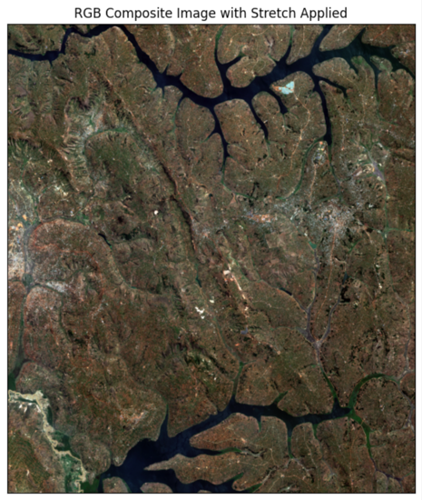

Figure 16: Example of a natural color (RGB) image

#### Vegetation Indices

Vegetation indices in the context of Earth observation refer to mathematical algorithms that use reflectance or radiance data from different EO bands to quantify the amount and health of vegetation on the Earth's surface. These indices are calculated using specific spectral bands from multispectral or hyperspectral remote sensing data that are sensitive to various vegetation properties, such as chlorophyll content, leaf area, and plant cell structure.

The primary purpose of vegetation indices is to emphasize the unique spectral characteristics of vegetation and minimize the influence of external factors like atmospheric conditions, soil background, and illumination variations. By mathematically transforming different spectral bands, vegetation indices can help differentiate between vegetated and non-vegetated areas, monitor changes in vegetation cover, and assess plant health and stress.

**Normalized Difference Vegetation Index (NDVI):** One of the most widely used vegetation indices, NDVI is calculated as the normalized difference between the red and near-infrared (NIR) bands (B4 and B8 in Sentinel 2):

NDVI = (NIR - Red) / (NIR + Red)

Areas with high crop density or healthy vegetation will absorb most of the red light for photosynthesis and reflect a large portion of the NIR light, resulting in higher NDVI values. In contrast, non-vegetated areas, such as urban or water features, will have low or negative NDVI values due to their different spectral characteristics.

NDVI values range from -1 to 1[17], with higher values indicating denser, healthier vegetation, and lower values suggesting sparse or stressed vegetation. Negative values usually indicate water bodies, as they absorb most of the NIR light, while values close to zero are associated with barren land, built-up areas, or sparse vegetation. NDVI has numerous applications in agriculture, forestry, and environmental monitoring, such as assessing crop health and productivity, monitoring drought, and detecting land-use changes.

The figure below demonstrates two NDVI images using different graduated green color mappings, with NDVI values normalized to values between 0 and 1. The choice of color mapping is often left to the discretion of the analyst. However, when building NDVI visualizations (and other types of band combination plots) it often makes sense to use intuitive color schemes. In the left-hand plot, green to light green / yellow indicates high NDVI values, corresponding to high levels of vegetation. Dark green to blue values in indicate lower NDVI values, corresponding to non-vegetated areas and water. The middle plot shows the same information, but with a different color ramp – which may be more useful depending on the context. On the right, side we have a RGB image of the same AOI for comparison. Comparing the RGB image to the NDVI images we can see that indeed, the built-up urban areas and water bodies correspond to lower NDVI values.

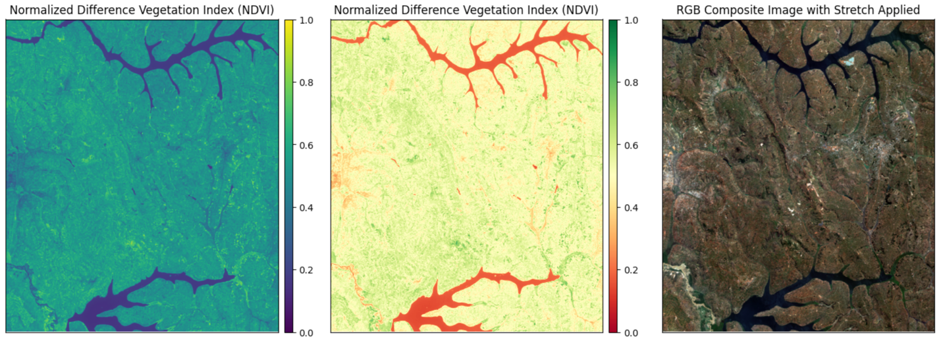

Figure 17: EO images demonstrating the difference between NDVI and RGB band combinations

**Soil-Adjusted Vegetation Index (SAVI):** SAVI is used to assess and monitor vegetation health while minimizing the influence of soil background noise. It is an enhancement of NDVI, which is known to be sensitive to soil brightness, especially in areas with sparse or low vegetation cover.

SAVI was developed to address the limitations of NDVI by incorporating a soil brightness correction factor (L), which adjusts the index based on the amount of vegetation present in the scene. The value of L typically ranges between 0 and 1. A higher value of L is used in areas with low vegetation cover, where soil brightness has a more significant influence on the index, while a lower value is used in areas with dense vegetation. As with NDVI, SAVI values range from -1 to 1. The formula for SAVI is as follows:

SAVI = ((NIR - Red) / (NIR + Red + L)) * (1 + L)

The figure below demonstrates two SAVI images using different values (0.1 and 0.9 respectively) for the soil brightness correction factor. As we would expect given the equation, values close to zero result in a plot that looks very similar to the NDVI plot for the same AOI (above). Values closer to 1 have a pronounced effect on the image, limiting the contrast. In this particular image, SAVI does not offer much advantage over NDVI as the AOI has significant vegetation cover.

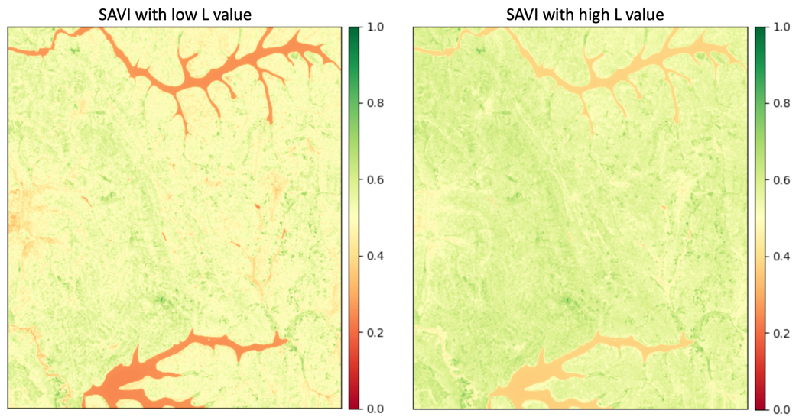

Figure 18: SAVI using differing L values

**Visible Atmospherically Resistant Index (VARI):** VARI is a band combination that uses only visible spectral bands (Red, Green, and Blue) to estimate vegetation cover and health. VARI was developed to address the limitations of other vegetation indices, such as NDVI and SAVI, which rely on the near-infrared (NIR) band, which is not available in some satellite datasets.

VARI is based on the principle that healthy vegetation absorbs more blue and red light while reflecting more green light. In contrast, non-vegetated surfaces such as soil, water, or urban features exhibit different spectral characteristics. By exploiting these differences, VARI can provide a quantitative measure of vegetation presence and health. By utilizing only visible bands, VARI is less sensitive to atmospheric effects than indices like NDVI, which rely on NIR bands. However, VARI may not always be as accurate in detecting subtle differences in vegetation health or density compared to indices that incorporate NIR information.

The index ranges from -1 to 1, with positive values indicating the presence of vegetation and negative values indicating non-vegetated areas. The formula for VARI is as follows:

VARI = (Green - Red)/ (Green + Red - Blue)

The figure below shows a VARI image using the same AOI as the previous examples. As we can see from the image, there is much less contrast between high and low index values compared to NDVI. This illustrates the value of including NIR in certain contexts.

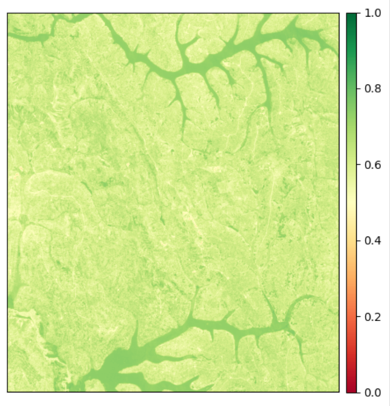

Figure 19: VARI image

#### Water Indices

Water indices can help us to detect, delineate, and monitor water bodies and their properties using EO data. These indices exploit the distinct spectral characteristics of water compared to other land cover types such as vegetation, soil, or urban features. Water indices play a critical role in various applications, including water resource management, flood mapping, wetland monitoring, and environmental impact assessments.

**Normalized Difference Water Index (NDWI):** NDWI is used to differentiate between water and non-water features. It is calculated using the green and NIR bands, as water bodies have higher reflectance in the green band and lower reflectance in the NIR band.

Water bodies have higher reflectance in the green band and lower reflectance in the near-infrared (NIR) band. The NDWI formula takes advantage of these spectral differences to emphasize water features. The formula is as follows:

NDWI = (Green - NIR) / (Green + NIR)

NDWI values typically range between -1 and 1. Higher positive values indicate the presence of water, while lower or negative values suggest non-water features such as vegetation, soil, or built-up areas. The effectiveness of NDWI can be affected by factors such as water turbidity, atmospheric conditions, and the presence of aquatic vegetation.

**Modified Normalized Difference Water Index (MNDWI):** The MNDWI is used to enhance the detection and mapping of water bodies in satellite imagery. It is a modification of the Normalized Difference Water Index (NDWI) and is designed to improve the discrimination between water and other land cover types, such as built-up areas, vegetation, and soil.

MNDWI modifies the original NDWI formula by replacing the near-infrared band with a mid-infrared (MIR) or shortwave infrared (SWIR) band. Water bodies have higher reflectance in the green band and lower reflectance in the MIR or SWIR bands. MNDWI values typically range between -1 and 1.

The figure below demonstrates a comparison between NDWI and MNDWI images using the same AOI. As we can see in the image on the right, MNDWI does a better job of revealing smaller water bodies than standard NDWI.

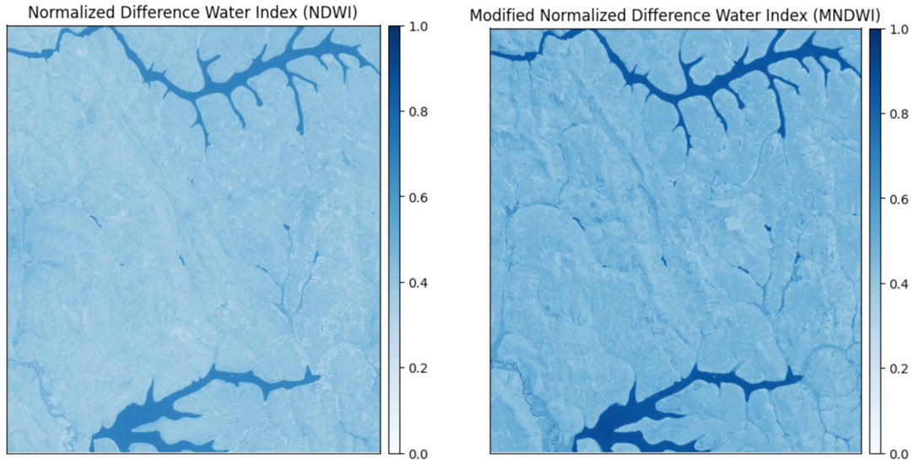

Figure 20: Comparison of NDWI and MNDWI

**Normalized Difference Moisture Index (NDMI):** NDMI is used to assess and monitor vegetation moisture content. It is particularly useful for applications such as drought monitoring, fire risk assessment, and evaluating water stress in agricultural areas. NDMI provides an estimate of the vegetation's liquid water content, which can help in understanding plant health, water availability, and susceptibility to wildfires.

Healthy vegetation has higher reflectance in the NIR band and lower reflectance in the SWIR band due to its moisture content. The formula is as follows:

NDMI = (NIR - SWIR) / (NIR + SWIR)

NDMI values typically range between -1 and 1. Higher positive values indicate higher vegetation moisture content, while lower or negative values suggest lower moisture content or non-vegetated surfaces.

The image below shows an NDMI image using the same AOI as the previous examples. From the image, we can conclude that most of the AOI is close to the middle of the index, likely indicating that the image was captured during a dry season.

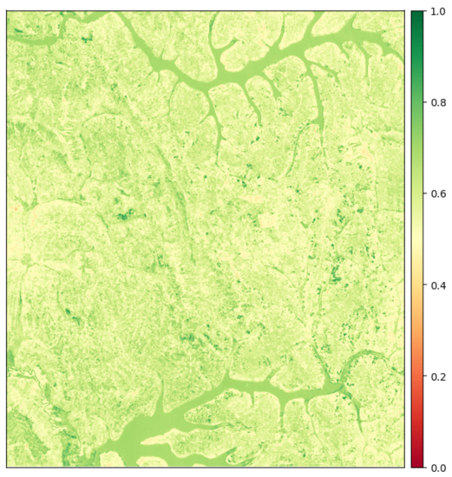

Figure 21: NDMI image

#### Geology Indices

**Clay Minerals Ratio (CMR):** CMR is used to identify and map the distribution of clay minerals in soil and geological formations. Clay minerals are a critical component of soil and play a significant role in soil fertility, water retention, and soil structure. Identifying clay minerals is also essential in geological studies, mineral exploration, and environmental assessments.

High CMR values indicate the presence of clay minerals, while lower values suggest a lack of clay minerals or the presence of other types of minerals or materials. The formula for the Clay Minerals Ratio is:

CMR = SWIR1 / SWIR2

The image below shows a CMR image using the same AOI as the previous examples. From the image, we can identify high clay mineral composition in the soil at various locations in the AOI. In particular, there appears to be a rich line of soil in the lower right corner.

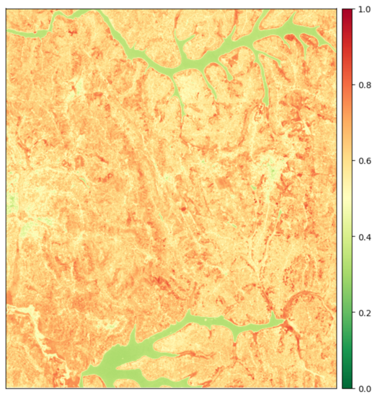

Figure 22: CMR image

**Ferrous Minerals Ratio (FMR):** FMR is used to identify and map the distribution of ferrous minerals, such as iron oxides and hydroxides, in soil, rock, and geological formations. Ferrous minerals are essential components of Earth's crust and play a significant role in various applications, including mineral exploration, soil fertility assessment, geological mapping, and environmental studies.

High FMR values indicate the presence of ferrous minerals, while lower values suggest a lack of ferrous minerals or the presence of other types of minerals or materials. The formula for FMR is as follows:

FRM = SWIR / NIR

The image below shows a FMR image using the same AOI as the previous examples. From the image, it appears the geographical composition of the location represented by the image contains almost no iron.

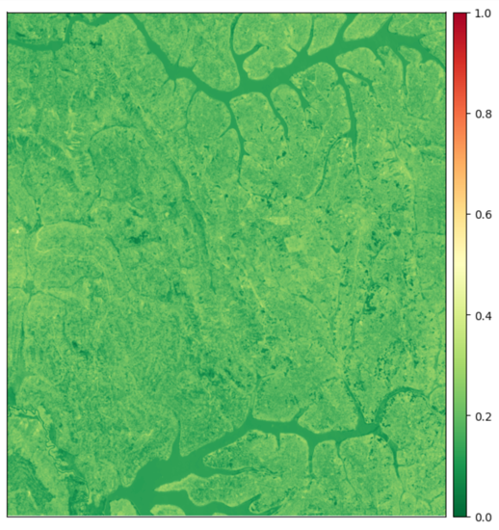

Figure 23: FMR image

**Band Stacking**

As we have seen in our exploration of satellite sensor spectral bands and band products visualization, there is significant value in combining different band combinations for particular analytical objectives. However, the actual process of creating data objects to support these analyses – band stacking - is not always straightforward due to various compatibility.

Band stacking refers to the process of stacking multiple spectral bands from an EO image into a single, multi-dimensional image. Band stacking is often used to increase the size and complexity of the data, to support more advanced analysis and interpretation of the data, or to enable the use of machine learning algorithms on the data. Here we will briefly discuss some of the considerations involved with band stacking. We will also cover this on a practical level in the python-based exercises.

Bands are easily **stackable if they have the same spatial resolution and cover the same geographic area[18]**. Therefore, the process of band stacking typically involves the following components:

* Spatial resolution matching
* Spatial geography alignment

**Resolution matching:** As we have seen above, our Sentinel 2 bands have differing spatial resolutions from 10 to 60 meters per pixel. To create stacked images for the AOI used in the above examples, we first need to resample all bands to the same spatial resolution.

As discussed in section 5.3, image resampling involves adjusting the image resolution up or down based on some reference image resolution. In the Sentinel 2 scenario, we may choose to upsample our low resolution (i.e. 60 meter) bands to match our high resolution (i.e. 10 meter) bands - or the opposite. However, it is extremely important to consider the (usually) inverse relationship between compute resource requirements and model accuracy in the resampling approach[19]. In either case, all images to be stacked must have the same resolution prior to stacking.

**Geography alignment:** In cases where all band data is sourced from the same platform and captured at the same time, it is not usually necessary to perform any geographical alignment of the different bands for a given AOI. This element of band stacking is usually only necessary when creating custom composites that focus on the spectral characteristics most relevant to a particular application. For example, if may be desirable to combine raw data from different satellite platforms or across different time periods. Given the complexity and limited use cases for geographical alignment in standard workflows, we will not cover practical application of this method in the exercises.

**Considerations:** As with resampling decisions, it is important to consider the downstream effects of band stacking on compute resources – particularly when building a training dataset. While it may be tempting to simply stack all desired bands together as a single data object in python, each additional band will add to the overall size of the object. This can have severe impact on resources when training a model or performing inference. Therefore, **when curating a dataset to be used in machine learning, it is better to keep band stacking to an absolute minimum**. For instance, if all we need for our model is NDVI, then we should only include Red and NIR bands in our stacked image data.

1. Photo by [Ethan Rheams](https://unsplash.com/@ethan_rheams?utm_source=unsplash&utm_medium=referral&utm_content=creditCopyText) sourced from [Unsplash](https://unsplash.com/s/photos/remote-sensing?utm_source=unsplash&utm_medium=referral&utm_content=creditCopyText)
2. This type of functionality is also available in the main computer vision libraries (e.g Keras)
3. Image source: Liu, Y.; Zhong, Y.; Fei, F.; Zhu, Q.; Qin, Q. Scene Classification Based on a Deep Random-Scale Stretched Convolutional Neural Network. *Remote Sens.* **2018**, *10*, 444. https://doi.org/10.3390/rs10030444
4. We will discuss techniques for directly addressing these issues in section 5.3. However it’s also important to understand how to compensate using augmentation. For instance, in some regions of the world, a significant proportion of available data suffers from cloud cover.
5. In many cases, EO images use 16-bit radiometric resolution (bit depth) resulting in an available pixel value range from 0 to 65,535. However images can vary depending on the data provider and the specific processing algorithms used. For example, Sentinel-2 images in Google Earth Engine are typically stored in 16-bit radiometric resolution.
6. Source: <https://cs231n.github.io/neural-networks-2/>
7. Source: <https://www.mathworks.com/help/images/image-enhancement-and-restoration.html>

   <http://giswin.geo.tsukuba.ac.jp/sis/tutorial/remote_sensing_image.pdf>
8. Source for Dilation and Erosion figures: <https://www.javatpoint.com/opencv-erosion-and-dilation>
9. <https://voxel51.com/fiftyone/>
10. Source: <https://towardsdatascience.com/exploratory-data-analysis-ideas-for-image-classification-d3fc6bbfb2d2>
11. Source: <https://towardsdatascience.com/dimensionality-reduction-using-t-distributed-stochastic-neighbor-embedding-t-sne-on-the-mnist-9d36a3dd4521>
12. Li, X., Zhou, Y., Zhao, M. et al. A harmonized global nighttime light dataset 1992–2018. Sci Data 7, 168 (2020). https://doi.org/10.1038/s41597-020-0510-y
13. Source: <http://dx.doi.org/10.3390/info11060322>
14. If you would like to learn more we suggest the following resources: [Edge Detection | Papers With Code](https://paperswithcode.com/task/edge-detection) <https://doi.org/10.3389/frsip.2022.826967>
15. <https://bigearth.net/#about>
16. Source: <https://gisgeography.com/sentinel-2-bands-combinations/>
17. All index values used in the example plots have been normalized to the range [0, 1] during analysis. Normalizing the values in python can make it easier to compare index values between different images or datasets, as the values are all on the same scale. It can also make it easier to visualize the index values using a color map, as the normalized values can be directly mapped to colors.
18. Spectral resolution may also play a role here depending on the data source (i.e. 8bits vs. 16bits etc)
19. Refer to section 5.3 for discussion on the trade-offs and considerations involved with image resampling